THREE YEAR OLD
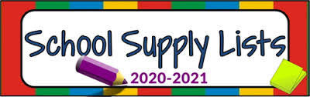

1 - Supply box
1 - Pack of colored pencils
1 - Pack of primary fat sharpened #2 pencils
1 - Box of crayons (regular size)
1 - Bottle Elmer’s Glue
3 - Glue sticks
1 - Scissors (Blunt tip)
1 - Art smock
1 - Plastic folder
1 – Primary composition notebook

Child’s personal needs:

2 - Pack of wipes
For students own personal use.
2 - Boxes tissue
2 - Bottle of hand Sanitizer
2 - Disinfecting Wipes

1 - Blanket & crib size fitted sheet (Must fit in cubby)
2 - Change of clothes (school uniform)
* No Book bags (CDC Regulation)
*No lunch boxes (Zip lock or Brown bags only)

*Please have all supplies and personal belongings labeled with your child’s name.

Thank you,

3-year-old classroom staff

